**ROLES AND RESPONSIBILITES:**

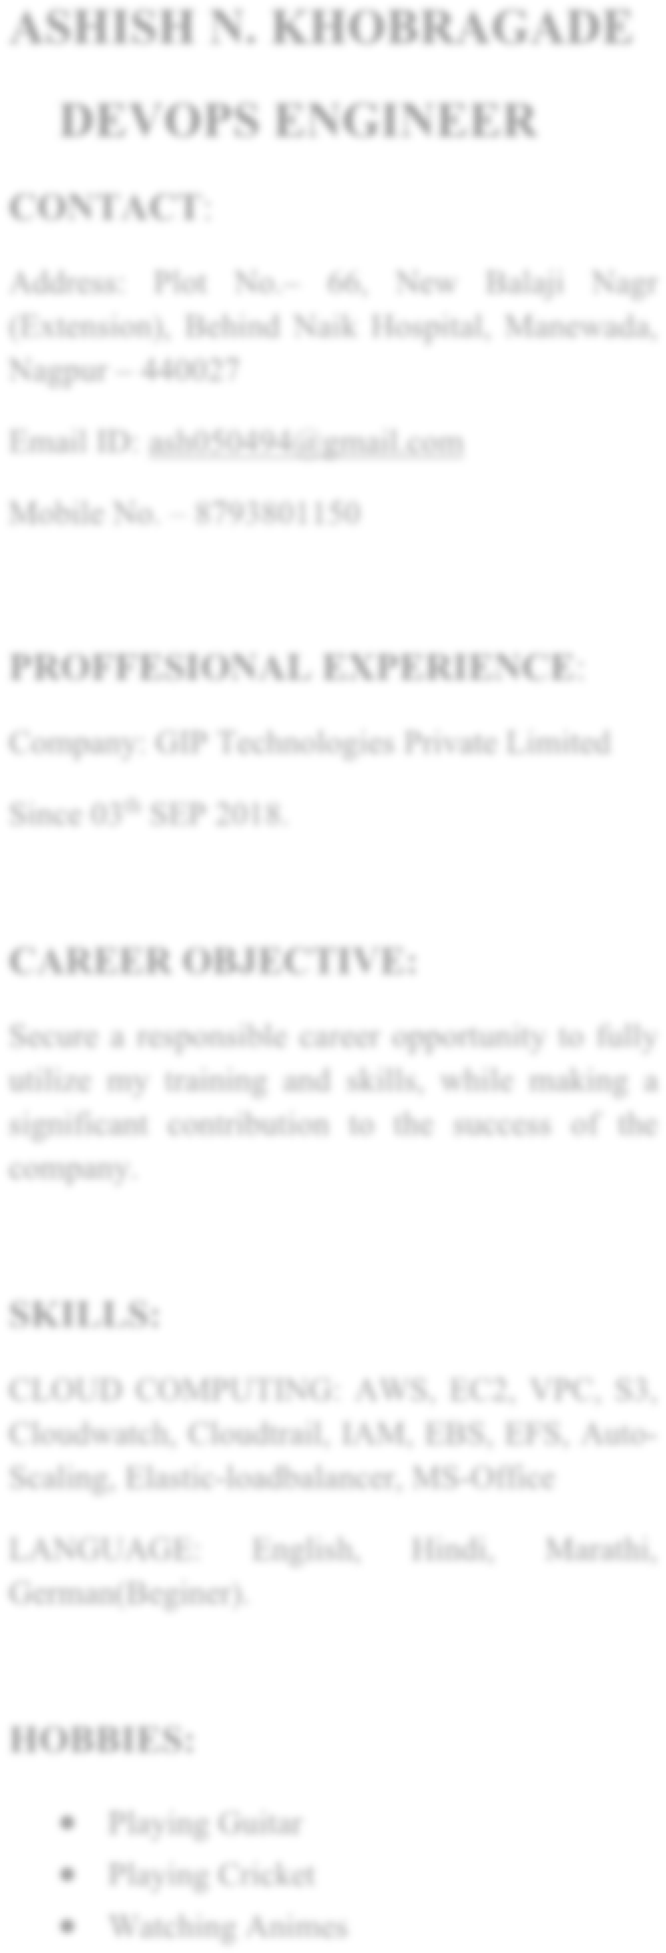

# STRENGTH



**CURRICULUM -VITAE**

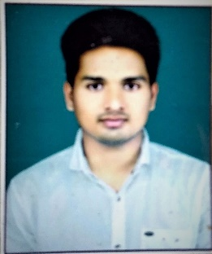

**Address: At. Post Chimur Ta. Chimur Dist. Chandrapur, 442903**

**Ganesh Sudhakar Gohane**

**Email ID:--**

ganeshsgohane@gmail.com

**Mobile No.:--**

**8766748419, 7798195143**

**EXPERIENCE  
Organization: --  
Designation:--  
Responsibility:--**

**CAREER OBJECTIVE:**

**Secure a responsible career opportunity to**

**Fully utilized my training and skills,  
 While making significant  
 Contribution to the success of company** .

**SKILLS:--**

**CLOUD COMPUTING: AWS, EC2, VPC, S3**,

**Cloudwatch, IAM, EBS, EFS, Auto**

**Scaling, Elastic**

**loadbalancer**

**HOBBIES**

# STRENGTH

**I am self-motivated Person.  
I am dedicated to my work.  
I am hardworking person.  
I am a Quick learner & Self-Motivated person.**

**Read Story books.**

**Playing Cricket.**

**Traveling**.

# LINUX:--

* Good Knowledge of Linux, Installation of Linux in different modes.
* Create Maintain and manage user in Linux system.
* Involved in installing virtual OS, monitoring Processes.
* Knowledge in booting and shutdown procedure.
* Installing and Upgradation of OS, Kernal and additional package using RPM and YUM.

• Good Knowledge of File system management and ACL and backup tools.

• Configure Cron-tab, and scheduling the jobs.

• Performing troubleshooting on internal network communications.

• Organized and Monitored logs, Services, disk usage and swap memory.

• Management of Archiving and Configure of file.

• Configured centralized log server to keep the backup of log files at one place.

• Framed and Designed volume size by using LVM.

• Compiled and Monitored remote server by using SSH  
 I have work on some Linux CLI services like SSH, HTTP, NFS, FTP, Samba, Maria-DB, DHCP, & DNS .

• Controlled inbound traffic of network by using FIREWALL.  
  
**AWS:--**

• Create User, Group, Policy and Role in IAM Service.

* I have work on S3 service for Creating bucket and manages bucket versioning, server access logging, handed static web hosting, bucket policy & replication of bucket with cross region as well as cross account.
* I have work on EC2-service with Launch webserver & manage there Security group, provide keys pairs & creating own Ami, snapshots, volumes on AWS EC2 –service.
* I have work on VPC service for creation of VPC, subnet, route table, NAT, Internet gateway, end point and peering connections.
* I have work on AWS route-53 service with hosting Website with specific domain name.
* Also, I have been work on some other AWS services like Lambda for deploy code, SNS for notification service , Dynamo-DB for non-relational databases, RDS for creation of Relational database and so on.
* I have work on Tomcat apache web server for automatic to Host and Deployed Java base Webserver and Automatic Creation of Databases.
* I have work on some monitoring services like cloud watch for monitor all resources of AWS.
* I have work on specific task like F-stab issue, grub-issue, mount S3-bucket on ec2 Instance, hosting website on http and https webserver, 3-vpc peering, Cross account Bucket sharing, cross account Bucket replication object,Route-53 failover and weighted policy, creation of Non-bootable ec2 with the creation of Non-bootable AMI, Volume ,and snapshot and so on.

# EDUCATION

**2015 – 2018 – B.SC.** (Computer Science) from Gramgeeta Mahavidyalaya

Chimur Dist. Chandrapur (From Gondwana University Gadchiroli)

|  |  |  |  |  |  |
| --- | --- | --- | --- | --- | --- |
| **Qualification Obtained** | **Collage**  **Name** | **Year of Passing** | **Board / Institute** | **Marks Obtained(% or CGPA)** | **Grade** |
| **SSC** | **Neharu**  **Kanishtha**  **Mahavidyalaya**  **Chimur** | **2013** | **Nagpur** | **77.00 %** | **First class** |
| **HSC** | **Neharu**  **Mahavidyalaya Chimur** | **2015** | **Nagpur** | **66.00%** | **First class** |
| **MS-CIT** | **Phonix**  **Computer**  **Institute,**  **Chimur** | **2013** | **Mumbai** | **93.00%** | **First class** |
| **Typing -30 (English)** | **Shri. Gajanan**  **Typing**  **Institute,**  **Chimur** | **2016** | **Pune** | **61.00%** | **First class** |

|  |  |
| --- | --- |
| **PERSONAL DETAILS** |  |
| Father's Name | Sudhakar G. Gohane |
|  |  |
|  |  |
|  |  |
|  |  |
|  |  |
|  |  |
| Address | At. Post Chimur Ta. Chimur Dist. Chandrapur,442903 |
| Date Of Birth  Gender  Marital Status  Nationality  Language | 20/03/1997  Male  Single  Indian  English , Marathi , Hindi |
| **DECLARATION** |  |

I hereby declare that the particular furnished above are true to the best of my knowledge and I bear the responsibility for the correctness of the above mentioned particulars.



**DATE - SIGNATURE**